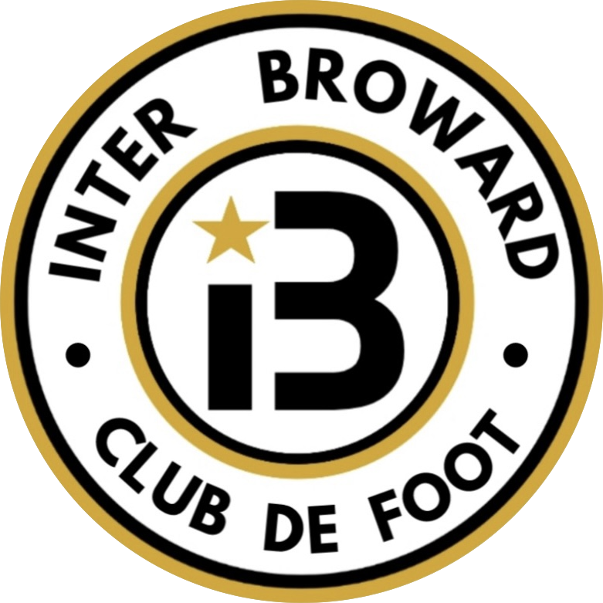
2026-27 COMMUNITY PARTNERSHIP OPPORTUNITIES

Support the player.
Strengthen the community.
A practical sponsorship platform for local organizations that want to support youth development in Coconut Creek.
Club | Inter Broward Club de Foot | Location | Sabal Pines Park, Coconut Creek
Players | Boys and girls ages 5-16 | Contact | 954-504-1315

THE OPPORTUNITY
Help expand player access, strengthen training resources, and create positive local experiences while connecting your organization with youth-sports families.
interbroward.com/sponsorship | interbroward.cf@gmail.com

THE PARTNERSHIP CASE

Why partner with Inter Broward CF?
Inter Broward CF is a player-focused youth soccer club and academy serving Coconut Creek families. The club combines purposeful coaching, small-group development, futsal, and positive standards for boys and girls ages 5-16.
VALUE PROPOSITION
This is a community-alignment opportunity. The strongest sponsor value comes from relevant local stories, useful family engagement, and clearly fulfilled activations - not inflated impression promises.

What sponsorship can enable
- Player access: help more dedicated local players participate in a positive development environment.
- Equipment and resources: support training equipment, uniforms, and materials that improve the player experience.
- Community programming: strengthen camps, matches, and family-focused activities.
- Club storytelling: help the academy share useful parent education and player-development content.

Club facts at a glance
Club fact | Current information
Players served | Boys and girls ages 5-16
Training location | Sabal Pines Park, 5005 NW 39th Ave, Coconut Creek, FL 33073
Field training | Monday and Thursday, 6:00-7:30 PM
Futsal | Tuesday, 6:00-7:30 PM
Family entry point | Up to two free trial sessions

RECOMMENDED STARTING POINTS

Partnership levels
The amounts below are recommended starting points for the 2026-27 season. Final scope, timing, and recognition should be confirmed in a written agreement before payment or public announcement.
Level | Investment | Best for | Recognition and activation
Community Partner | $500 | A simple local-support entry point | Sponsor-page listing; one social thank-you; digital partner badge.
Player Access Partner | $1,000 | Supporting participation or family access | Community benefits plus newsletter recognition and one dedicated partner feature.
Training Partner | $2,500 | Equipment, camps, or training resources | Player Access benefits plus select digital-material recognition and one agreed activation.
Premier Club Partner | $5,000+ | A customized season partnership | Prominent sponsor-page placement, campaign storytelling, and a negotiated activation plan.

Ways to customize
- Player-access or equipment focus tied to a specific agreed need.
- A sponsored parent guide, camp, or community activity.
- A trackable digital campaign that sends families to a useful club resource.
- An approved on-site presence when facility and event rules permit it.
IMPORTANT
Logo placement, event presence, apparel or jersey recognition, photos of minors, and platform mentions are available only when specifically agreed and permitted. No audience size, lead volume, or business result is guaranteed.

ACTIVATION AND ACCOUNTABILITY

A simple path to partnership
- Choose the goal. Identify whether the priority is player access, equipment, community programming, or brand connection.
- Confirm the package. Document investment, recognition, timing, content approvals, and a primary contact for each organization.
- Activate with purpose. Launch the agreed digital, community, or event activity with clear calls to action.
- Report what happened. Share a short fulfillment summary with completed deliverables and available engagement indicators.

What can be measured
- Completion of agreed sponsor benefits and content placements.
- Clicks from tagged sponsor links to the club website.
- Website contact actions associated with the campaign, when available.
- Participation in an agreed camp, event, or community activation.
- Qualitative feedback from club families and the sponsor team.

Start the conversation
Share your organization, preferred investment range, timing, and the kind of community impact that matters most. Inter Broward CF will recommend a practical scope and document the final terms.
CONTACT
Inter Broward Club de Foot | 954-504-1315 | interbroward.cf@gmail.com | interbroward.com/sponsorship
Status note: This package describes sponsorship and community-partnership opportunities. It does not represent that payments are charitable or tax-deductible. Sponsors should rely on the final written agreement and their own professional advisers.

